To verify our model strain rate amplitudes, we compare the analytic 2-D shear strain solution to a measurement acquired from Durmid Hill Laser Strainmeter (DHLS) (D. Agnew, pers. comm.).

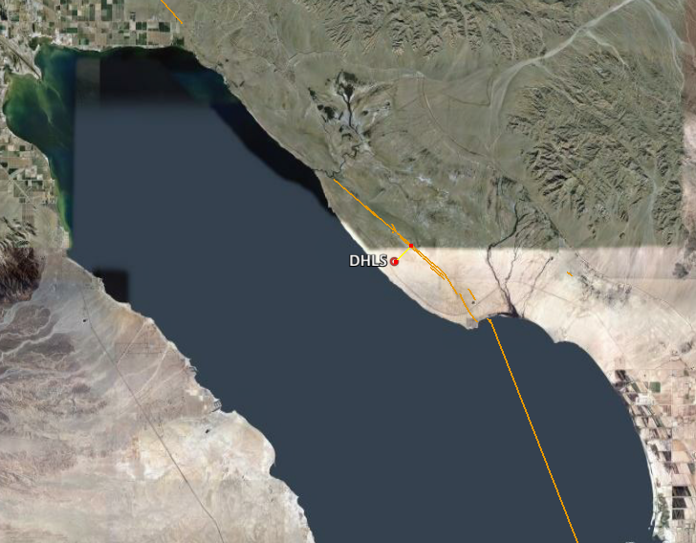
Fig. 1. Durmid Hill Laser Strainmeter (DHLS) location, ~ 1.5 km SW of the San Andreas fault.

We begin with the 2-D analytic shear strain solution for a strike-slip dislocation embedded in a homogeneous elastic half-space [Weertman, 1964].

$$e_{\text{xy}}=\frac{V_{o}}{p}\left[\frac{d}{x^{2}+d^{2}}\right]$$
(1)

where V_{o} = slip rate, d = locking depth, and x = distance across fault-plane.

For this analysis, we compare analytic models at 1) constant slip rate (V_{o} = 25 mm/yr) and variable locking depths (d = 1, 5, 10 km), and 2) constant locking depth (d = 8 km) and variable slip rates (V_{o} = 20, 30, 40 mm/yr). These results are show in Figs 2-3.

Strain rate tensor components from DHLS are ε_{yy} = -230 nanostrain/yr and ε_{xx} = 330 nanostrain/yr. Note that ε_{xy}, not provided, is assumed to be small (D. Agnew, pers. comm.). To compare these measurements with the analytic shear strain equation, we approximate maximum shear strain (ε_{shear}) using the following equation:

$$e_{\text{shear}}=2\sqrt{{\left(\frac{e_{\text{xx}}−e_{\text{yy}}}{2}\right)}^{2}+{\left(\frac{e_{\text{xy}}}{2}\right)}^{2}}$$
(2)

Using this equation, we obtain 560 nanostrain/yr for the shear strain rate at DHLS, assuming ε_{xy} = 0. We also note that the laser strainmeter is located ~ 1.5 km SW of the San Andreas fault (Coachella segment, Figure 1). As a side note and first-order check, we can also compute the shear stress rate, τ_{xy} = με_{shear}, assuming a shear modulus of 30 GPa, which yields 1.68 MPa/100 yrs. Smith-Konter and Sandwell (2009) report 1.8 MPa/100 yrs for an along-fault average Coulomb stress rate for this segment.
Fig. 2. 2-D strain rate as function of locking depth. V_{o} = 25 mm/yr.

Fig. 3. 2-D strain rate as function of slip rate. d = 8 km.
Our goal is to generate a strain rate curve, using a valid locking depth and slip rate, that matches the DHLS measurement 1.5 km from the fault (Fig. 4).

- For the model presented at the 2009 EarthScope meeting, we adopted a 25 mm/yr slip rate and an 8 km locking depth (green curve). This strain rate over-estimates the DHLS strain rate.
- Applying a deeper locking depth estimate from Smith and Sandwell (2003), a 14 km depth provides a good match the DHLS strain rate (red curve).
- Given implications that the slip rate on this section of the San Andreas may actually be lower than 25 mm/yr, we adjust the slip rate to 10 mm/yr (blue curve). To match the DHLS strain rate, a locking depth of 5 km is required for this model.

Fig. 4. Example 2-D strain rate profiles using 3 combinations of slip rate and locking depth. Green curve = EarthScope strain poster parameters; red curve = parameters from Smith and Sandwell (2003); blue curve = reduced slip rate on San Andreas.

Conclusions:
- The locking depth used for the EarthScope meeting strain analysis was likely too shallow (8 km vs. 14 km), and we are in the process of identifying the best locking depth for this fault segment using the EarthScope PBO dataset (work in progress). This estimate will be based on a 25 mm/yr slip rate assumption for the Coachella segment.
- If our new locking depth result for this segments yields a depth close to 14 km, then we will match the DHLS strain rate. If our new depth estimate is closer to 8 km, then we should consider adopting a lower slip rate to better match the DHLS strain rate measurement.
- LOCKING DEPTH IS AN IMPORTANT MODEL PARAMETER!

http://www.ecourses.ou.edu/cgi-bin/eBook.cgi?doc=&topic=me&chap_sec=08.1&page=theory

